Healing encounter
  - Oasis House is very excited to announce Healing Encounter weekend on March 17 & 18th at the beautiful Himawari Hotel. It’s not training, nor is it a seminar, but the purpose of this meeting is threefold: Healing, Comfort and Encounter.
After a longer than expected period of Covid, where so many of us had to endure hardship at many different levels, we feel our soul is dry and parched, we need healing!  But we know, streams of living water flows to those who seeks and finds… it’s an opportunity to dig deep into our spirit man and receive healing, comfort and encounter God. On a practical level, there will be Inner Healing learning and time of prayer, testimonies of healing, receive comfort and care from one another, and time to encounter God.  This Healing Encounter is largely sponsored by friend of Oasis from USA, so, there will only be minimum charge of $20 for the two days of awesome time including lunch at the hotel. So, come and experience this Healing Encounter with us. The schedule will be Friday 9am-5pm and Saturday 9am - 5pm. It is conducted in English  We are only taking 40 registers and will be first come first serve, and the deadline will be at the end of February 28. | 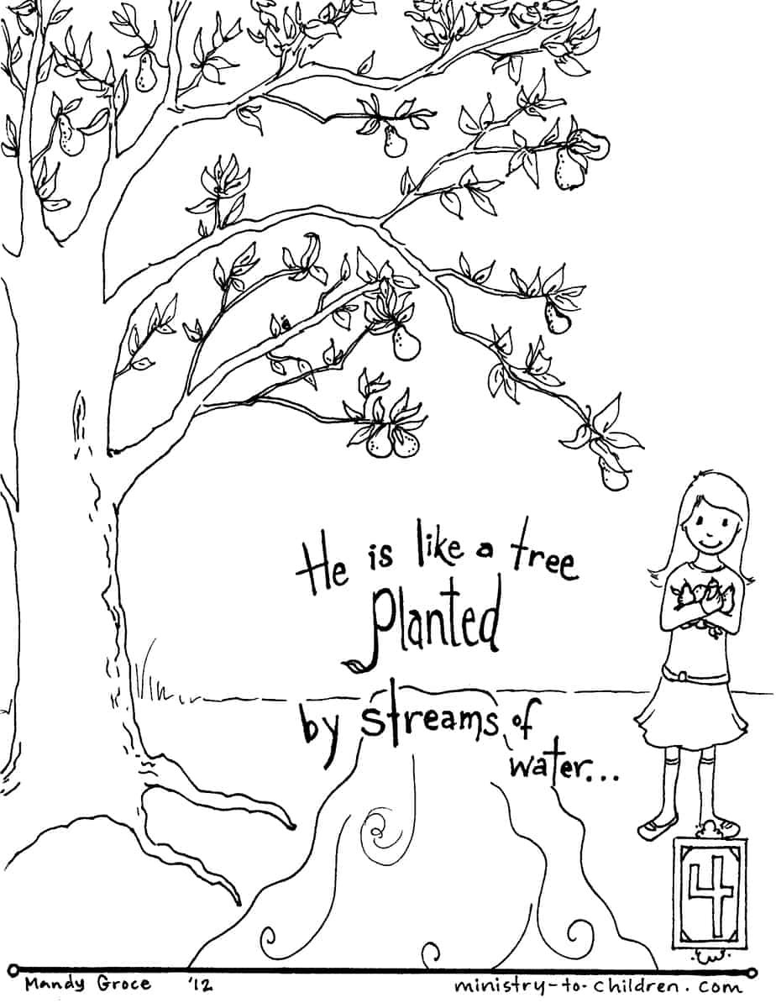

If you are interested in registering, please contact Sypho Dy at Oasis House  016 912 016, or email oasishousecambodia@gmail.com | 